**Lab Practical #02:**

Study of different types of network cables & connectors and practically implement the cross-wired cable and straight through cable using clamping tool.

**Practical Assignment #02:**

1. List various networks cable and connectors. Also, write short description.
2. Give cross-wired cable and straight through cable diagram (Color Code wise).

## List various networks cable and connectors. Also, write short description.

1. **Network Cable Name:** **Coaxial cable**
   * **Network Cable Type:** Guided
   * **Description**: Co-axial copper cables consist of inner copper conductor and an outer copper shield, which are separated by a di-electric insulating material, helpful in preventing signal losses. Copper co-axial cables used in cable TV networks and as trunk lines between telecommunication equipments. It serves as an internet access line from the home and supports medium to high data rates.
   * **Diagram**:

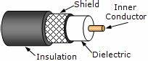

1. **Network Cable Name:** **Twisted Pair Copper**
   * **Network Cable Type:** Guided
   * **Description**: It is the most used media across the world. All the local telephone exchanges are made of twisted pair copper. These telephone lines are reused as last mile DSL access links to access the internet from home. Twisted pair copper wires are also used in Ethernet LAN cables within homes and offices. It supports low to High Data Rates which is in the order of Gigabytes. These wires are effective up to a maximum distance of a few kilometres/miles, because the signal strength is lost significantly beyond the distance. Generally, they come in two variants as follows −
   * UTP (unshielded twisted pair): The word unshielded in UTP refers to the lack of metallic shielding around the copper wires. By its nature, the twisted-pair design helps minimize electronic interference by providing balanced signal transmission, making a physical shield unnecessary. Unshielded twisted pair(UTP) is commonly used in home access.
   * STP (shielded twisted pair): Shielded twisted pair (STP) is a special kind of copper telephone and local area network (LAN) wiring used in some business installations. It adds an outer covering or shield that functions as a ground to ordinary twisted pair wiring.
   * For every variant, there are multiple sub-variants, based on the thickness of the material (like UTP-3, UTP-5, UTP-7 etc.)
   * **Diagram**:

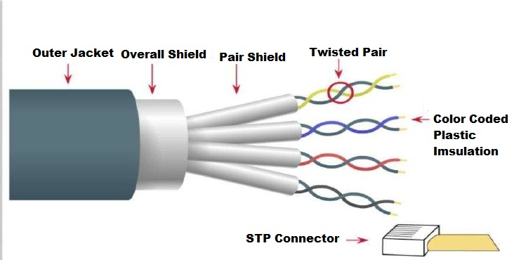

1. **Network Cable Name: Fiber Optic Cables**
   * **Network Cable Type:** Guided
   * **Description:** In fiber optic cable the information is transmitted by propagation of optical signals (light) through fiber optic cables and not through the electrical/electromagnetic signals. Because of this, the fiber optics communication supports longer distances as there is no electrical interference. The fiber optic cables are made of very thin strands of glass (silica). It supports high data rates.  It is used for accessing the internet from home through FTTH (Fiber-To-The-Home) lines.
   * Examples − OC-48, OC-192, FTTC, HFC.
   * **Diagram**:

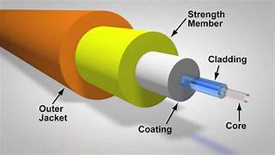

1. **Network Cable Name: Microwaves**
   * **Network Cable Type:** Unguided
   * **Description:** Microwaves travel in straight lines and therefore the narrow focus concentrates all the energy into a beam.  In microwaves periodic repeaters are necessary for long distances and for transmitting and receiving antennas are aligned accurately. Example − Bluetooth technology.
   * **Diagram**:

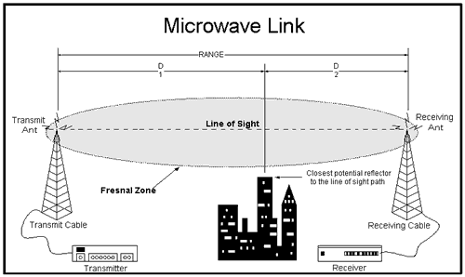

1. **Network Cable Name: Satellite**
   * **Network Cable Type:** Unguided
   * **Description:** It is a data communications network facilitated by one or more communication satellites on Earth's orbit. use microwave radio to protect from the atmosphere and act as a microwave relay station. They are situated in space 22,000 miles above the equator, and it appears stationary from the earth as it rotates with specific speed. They can amplify and relay microwave signals from one transmitter on the ground to another.
   * **Diagram**:

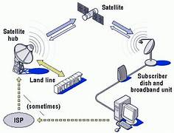

## Give cross-wired cable and straight through cable diagram (Color Code wise).

1. Cross-wired Cable Diagram (Color Code)

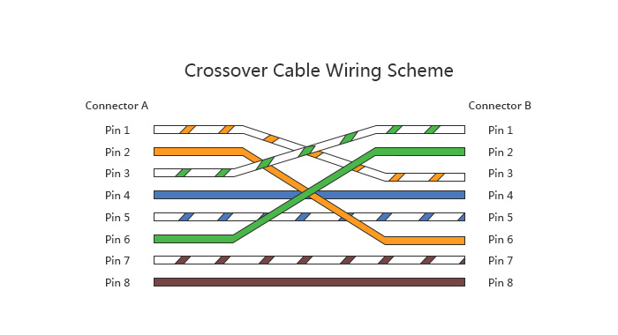

1. Straight Through Cable Diagram (Color Code)

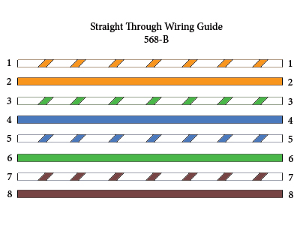

## Difference between Guided and Unguided Media

|  |  |  |
| --- | --- | --- |
| **Sr.** | **Guided media** | **Unguided media** |
| **1** | In guided media, the signal energy communicates via wires. | In unguided media, the signal energy communicates through the air. |
| **2** | Guided media is generally preferred when we want to execute direct communication. | Unguided media is generally preferred for radio broadcasting in all directions. |
| **3** | The guided media formed the different network topologies. | The unguided media formed the continuous network topologies. |
| **4** | Here, the signals are in the state of current and voltage. | Here, the signals are in the state of electromagnetic waves. |
| **5** | In the case of guided media, the transmission capacity can be boosted by counting more wires. | In the case of unguided media, it is not feasible to acquire more capacity. |
| **6** | Open Wire, Twisted Pair, Coaxial Cable, and Optical Fibre are the different kinds of guided media. | Microwave Transmission, Radio Transmission, and Infrared Transmission are the types of unguided media. |